Type 1 Conditional: for possible situations (Teacher version)
CHAU, Ka Ying
The Hong Kong Institute of Education
You are going to listen to Christine Glass’s songMy Love Will Get You Home. Find out why she sings the song. (https://www.youtube.com/watch?v=xiZvs9V3hGI)
Warm-up question: When you are unhappy, who will you turn to? Will you talk to your friends?

- First listening. Just listen(do not write anything). Listen for the following:
- Is ‘you’ in the song happy / unhappy? unhappy
How do you know? Give one example. Wander off too far, follow the wrong star
- Who does Christine sing the song for?People who are upset, lost
- Why does she sing the song? to encourage the listeners
- Listen to the song again more carefully. Fill in the missing words:
Words to explain  If you _wander______ off too far,  my love __will_____get you home.  If you __follow____ the wrong star,  my love __will______ get you home.  If you ever _find___ yourself,  lost and all alone,  get back on your feet and think of me,  my love __will____ get you home, boy,  my love _will_____ get you home.  If the bright lights __blind___ your eyes,  my love _will_____ get you home.  If your troubles __break____ your stride,  my love __will___get you home.  If you ever _find______ yourself,  lost and all alone,  get back on your feet and think of me,  my love__will____get you home, boy,  my love__will____get you home. | If you ever _feel____ ashamed,  my love _will________getyou home.  When there __is____ only you to blame,  my love __will_____ get you home.  If you ever __find_____ yourself,  lost and all alone,  get back on your feet and think of me,  my love __will_____getyou home, boy,  my love will get you home.  If you ever _find_____ yourself,  lost and all alone,  get back on your feet and think of me,  my love ___will___get you home, boy,  my love ___will____get you home, boy,  my love ___will____get you home.

- Now, complete the following sentences using the lyrics you have filled in.
- If you_wander______of too far, my love __will_____ get you home.
- If you __follow____ the wrong star, my love __will______ get you home.
- If the bright lights __blind___ your eyes, my love _will___ get you home.
- If your troubles __break____ your stride, my love __will__get you home.
- If you ever _feel____ ashamed, my love _will___get you home.

- Read the above 1st conditional sentences again. There are two parts in a sentence,
the if-clause and the main clause. Now, put (brackets) for the if-clause and underline the main clause. What tense is used in the if-clause? What tense is used in the main clause?

First Conditional
Structure:*Cross out the wrong answer.
(If-clause) | Main clause
e.g. If you _wander___ off too far, | my love __will__ _get_you home.
Present/Past tense Present | ___will __________  +  ___bare infinitive_
Follow- up questions:
(1) Apart from ‘will’, can we use other modal verbs in the main clause? e.g. may, can?
(2) How is the meaning changed if we change the lyrics to ‘my love can/may get you home’? (lower level of certainty)

Meaning:
We use the 1stconditional to talk about * facts / possible/ impossible situations. In the main clause, Present/Past/future tense is used to talk about situations which must/ may happen in the future.

- When something wrong has happened, some people may become superstitious and believe that this is due to bad luck. For example, in Hong Kong many people don’t want to live on the 14th door because they think that if they live on the 14th floor, they will have bad luck.
You are going to watch a video about Western superstitions. https://www.youtube.com/watch?v=8Fb1xw3eURQ.
Guess what people think will happen if they face the following situations.

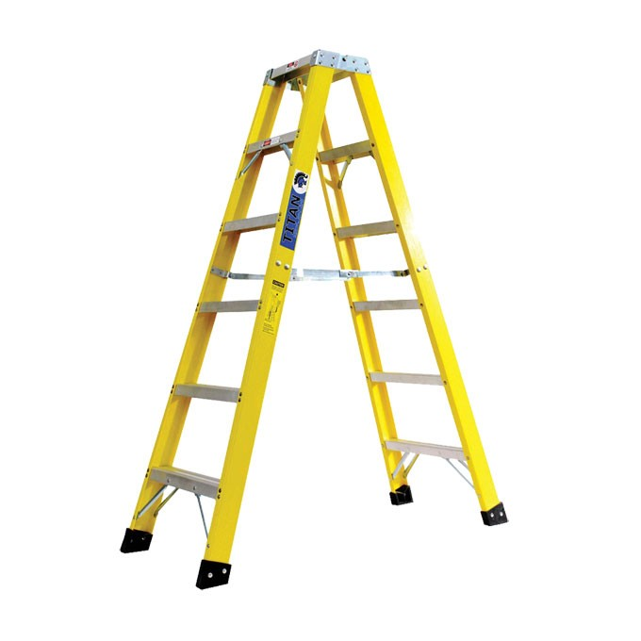
If a black cat ______ (walk) in front of you, ___________________________.
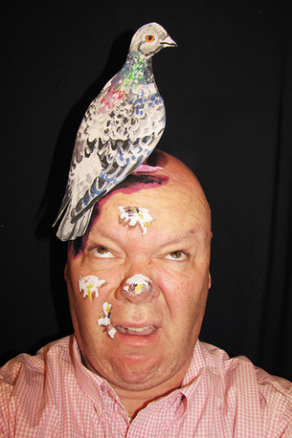
If you _____ (walk) under a ladder, _________________________________.
If a bird _____ (shit) on you, ________________________________________.
If you _____ (put) a broom upside down behind the door, __________________________.
If you _____ (open) an umbrella inside your house, ______________________________.
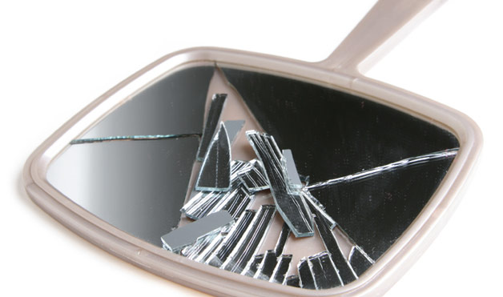
If you _____ (break) a mirror, ________________________________________________.

- Read your partner’s ideas. Check the tense used. Put a ‘√’ when correct tenses are used.
- What are the tenses used in the 1st conditional? Complete the following table.

If-clause | Main clause
___________________ tensePresent | __________________________ will/may/can  +  ___________________________bare infinitive
e.g. If you live on the 14th floor, | You will have bad luck.

- Watch the video about Western superstition. Write down what people think will happen if they face the following situations.
- If a black cat ______ (walk) in front of you, ______________________________.
- If you _____ (walk) under a ladder, _____________________________________.
- ______________________________________________ if a bird _____ (shit) on you.
- ________________________ if you _____ (put) a broom upside down behind the door.
- ____________________________ if you _____ (open) an umbrella inside your house.
- ____________________________________________ if you _____ (break) a mirror.

Compare Sentences 1-2 with Sentences 3-6.Where can we put the if-clause in a sentence? The if-clause can be put before or after the main clause.
Is the superstition a fact / guess? Guess
It is possible / a must for the superstition to happen? possible

Meaning of the 1st conditional
We use the 1st conditional to talk about *____ possible _situations. In the main clause, _the future tense is used to talk about situations which_may happen in the future.

- Miss Chan loves the song My Love Will Get You Home and has changed the lyrics to a new song Miss Chan will stand by you. Pair up and do the following:
- Which is an if-clause and which is a main clause?
- *Cross out the wrong verb forms.
- Match the if-clause and the main clause, and form logical 1st conditional sentences.

If you *will / do not study hard
If you *follow / will follow / will follows the school rules
you*get / may get / may gets failing marks.
Oh, Miss Chan *stand / will stand / will stands by you.
If you ever *find / will find / will finds yourself lost and all alone
Miss Chan *did not punish / wouldn’t punish / won’t punish you
Miss Chan *stand /will stand / will stands by you
The lyrics Miss Chan will stand by you
If you do not study hard, you will get failing marks.
If you follow the school rules, Miss Chan won’t punish you.
If you ever find yourself lost and all alone,
be positive and talk to me, Miss Chan will stand by you,
Oh, Miss Chan will stand by you.

Self-evaluation. Do you get it correct?
For 1st conditional sentences, we use the present tense in the if-clause. | Yes/No
For 1st conditional sentences, we use the future tense in the main clause. | Yes/No
Bare infinitives are used after modal verbs. | Yes/No

- Song Rewriting. Refer to the melody of the song My Love Will Get You Home. In pairs/groups, choose a topic from the following and rewrite the lyrics using 1st conditional sentences.

1. Chinese superstitions | e.g. If you cut your nails at night,  you will meet ghostly things.
2. misbehaviours in schools | e.g. If you don’t do your homework,  you will be in trouble.
3. or your creative idea (ask your teacher before you do it)

Some examples from my P.6 students

Student A Topic: Chinese Superstition
If you go to funerals, ghosts may follow you home.
If you cut hair at New Year, you will have bad luck.
If you knock a hotel door, smile and say hello,
be polite and say hello, ghosts won’t play tricks on you.
Oh, ghosts won’t play tricks on you.

Student B Topic: misbehaviours in schools
If you do not do homework, Miss Chau will punish you.
If your nails are too long, Miss Chau will cut them all.
If you ever wake up late, even miss the train,
be prepared for the detention, Miss Chau will stay with you.
AH! Miss Chau will wait for you.

