Conditional Type 2: If I did...
MAK, Pui Yee
The Hong Kong Institute of Education
What would you do if you had a million dollars? Barenaked Ladies has written a song If I had a million dollars. Find out what they would do if they had the money.
What would they do if they were rich?
(https://www.youtube.com/watch?v=AtV6h4g9eYw)
(0’21’’-1’46’’)
- First listening. Just listen (do not write anything). Listen for the following:
- Give one example of what they would buy if they had a million dollars. A house, furniture, etc.
- Do they have one million dollars now? No.

- Listen to the song again more carefully for the lyrics. Fill in the missing blanks:
If I had a million dollars (If I had a million dollars)
I’d buy you a house (I would buy you a house)
If I had a million dollars (If I had a million dollars)
I’d buy you furniture for your house
Maybe a nice chesterfield or an ottoman
If I had a million dollars (If I had a million dollars)
I’d buy you a K-Car, a nice Reliant automobile
If I had a million dollars, I’d buy your love.
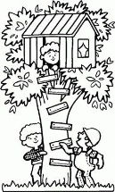
If I had a million dollars
I’d build a tree fort in our yard.
If I had a million dollars
You could help, it wouldn’t be that hard.
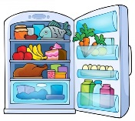
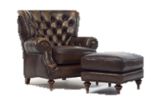
If I had a million dollars
Maybe we could put a little tiny fridge
in there somewhere
We could just go up there and hang out.
Like open the fridge and stuff, and there’d be foods laid out for us
With little pre-wrapped sausages and things. Mmmmm.
They have pre-wrapped sausages but they don't have pre-wrapped bacon.
Well can you blame
them? Yeah)

- Now, complete the following sentences using the lyrics you have filled in or your own ideas
(Note: I’d = I would. Please write I would below):
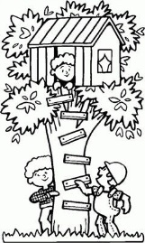
- If I had a million dollars, I ____ would buy _____ you a house.
- If I had a million dollars, I ____ would buy _____ you furniture for your house.
- If I had a million dollars, I__ would build __ a tree fort in our yard.
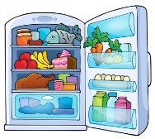
- If we built a tree fort, we __ could put __ a little tiny fridge there.
- If we built a tree fort, we__ would go up __ there and __ hang out __.
- If I had a million dollars, there __ would be __ foods laid out for us.

- What tense is used in the sentences in Question 3? *Cross out the wrong answers below.

The sentences above are Type 2 Conditional.

 | ( *past/ present tense) |  | (would/could/might + bare infinitive)
 | If I had a million dollars, |  | I would buy a house.
 | if-clause |  | main clause

For Type 2 Conditional, the situations in the if-clauses are *imaginary/ real in the present,
i.e. we do not expect having a million dollars to happen.

How is Type 2 Conditional different from Type 1 Conditional?

Type 1 Conditional :
 | ( *past/ present tense) |  | (will/can/may + bare infinitive)
 | If I study hard, |  | I will have good results.
 | if-clause |  | main clause

We use Type 1 Conditional to talk about * possible/ impossible situations.

- Below are example sentences of Conditional sentences. However, some contain mistakes. Work in pairs:
- Decide which is correct and which is wrong.
- Explain to your partner.
 |  | Correct or wrong?
1a | If trees gave off Wi-Fi signals, we would plant many trees and save the planet. | _______
1b | 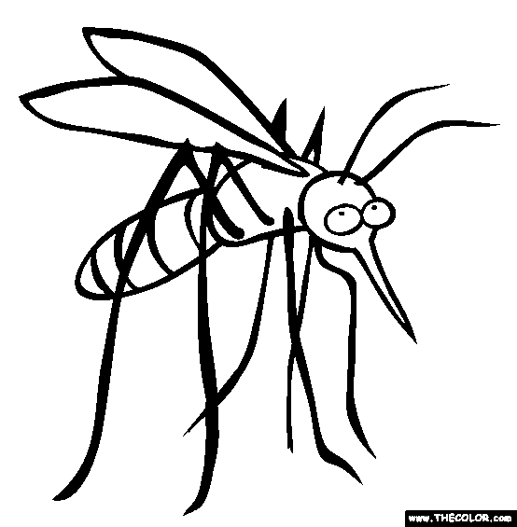  If trees give off Wi-Fi signals, we would plant many trees and save the planet. | _______
2a | If mosquitoes do not bite, everyone would love them. | _______
2b | If mosquitoes did not bite, everyone would love them. | _______
3a | We might not pick up the pen if the school cancelled exams. | _______
3b | We may not pick up the pen if the school cancelled exams. | _______
4a | I could chat with animals if I knew their languages. | _______
4b | I can chat with animals if I knew their languages. | _______
5a | I will go the Wetland Park if the weather is fine. Possible situation Type 1 | _______
5b | I would go to the Wetland Park if the weather was fine. Impossible situation Type 2 (if the weather is very bad now) | ________
6a | You will be knowledgeable if you study hard. Possible situation Type 1 | _______
6b | 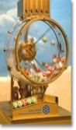  You would be knowledgeable if you studied hard. Impossible situation Type 2 (if you are very lazy and unlikely to study hard) | ______
7a | If I had a time machine, I would go back to 2004. Imaginary Type 2 | _______
7b | If I have a time machine, I will go back to 2004. | _______
8a | If I went back to 2004, I would win the 1st prize of Mark Six. Imaginary Type 2 | _______
8b | If I go back to 2004, I will travel to the future and win the 1st prize of Mark Six. | _______
9a | I will make a good living if I master English. Possible situation Type 1 | _______
9b | I would make a good living if I mastered English. Impossible situation Type 2 (if I can never master English) | _______
10a | I would donate to charity if I were you. | _______
10b | I will donate to charity if I am you. Imaginary Type 2 | _______

- Matching Game. Your teacher will give you slips of conditional sentences. Work in pairs.
1) Match the slips up to form logical conditional sentences.
2) Put them under Type 1 or Type 2 Conditional.
- Writing task
Alternative: Group work.
T assigns one magic item for each group and asks them to present the most creative idea to the class.
Let us watch a video about how Harry and his friends use their wands.
https://www.youtube.com/watch?v=zHPqO0UnaW8 (0’00-0’40)
Imagine you were one of the characters in Harry Potter. What would you do if you had magic power and the following magic items? Write a sentence for each item and share your ideas with your partner.
T can ask Ss to look for the most interesting idea from their partners.
e.g. If I had a magic wand, I would turn paper into banknotes.
1. magic wand  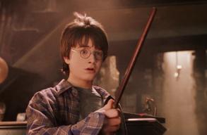  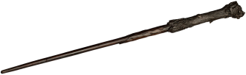 | ___If I had a magic wand, I would turn all pictures into real things._________________________________  _________________________________________________  _________________________________________________
__If I had a broomstick, I would fly to school and anywhere I want to go to. _______________________  ____________________________________________  ____________________________________________  ____________________________________________ | 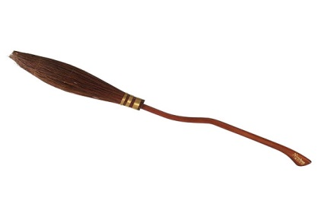  2. broomstick
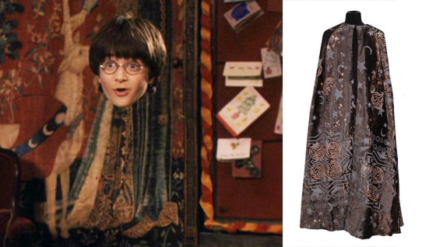  3. invisibility cloak | __If I had an invisibility cloak, I would get all candies from the tuck shop._____________________  _________________________________________________  _________________________________________________  _________________________________________________
__If I had an owl, I would write to my friends more often._________________________________  ____________________________________________  ____________________________________________  ____________________________________________ | 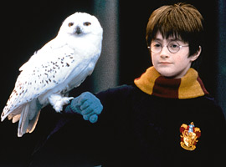  4. owl
5. time turner  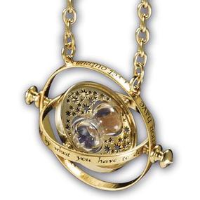 | ___If I had a time turner, I could control time and I would not be late for school any more._______________________________________  _________________________________________________  _________________________________________________  _________________________________________________

- Some songs to enjoy at home. In the following songs, Type 2 conditional sentences are used. Listen for the sentences and think about the meaning they make.
- Tears in heaven by Eric Clapton at https://www.youtube.com/watch?v=-SP7hXCZF_o
- If I Could Turn Back Time by Cher at https://www.youtube.com/watch?v=E9Vm9v4J-3E
- More Than Words by Extreme at https://www.youtube.com/watch?v=0R-FGchhwLw
- If I Were A Carpenter by Bobby Darin at https://www.youtube.com/watch?v=rlGS4EqmUDE

