Worksheet 1: Present Progressive
CHAN, Shuk Ling Heather
The Hong Kong Institute of Education

- Use a color pencil or a highlighter to highlight the Present Continuous Tense in the sentences.

e.g. What is he doing?
He is sleeping.

- What is she doing?
- She is eating diner.
- He is reading and writing.
- I am doing homework.
- She is jumping and swimming.
- He is playing baseball over there.
- He is throwing. | 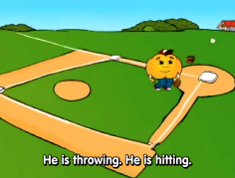
- He is hitting.
- He is running and he is catching.
- We are coming.

(Adapted from: https://www.youtube.com/watch?v=a6Eozn55Lqs)
- Mum/Dad is at work. She/he is calling to see what the family members are doing:
Mum/Dad: What is X doing? / What are X and Y doing?

Help Dad/Mum write down the
answers using present continuous tense while listening.

e.g. Mum/Dad: What is Mary doing?
You: Mary is washing the dishes.

Mum/Dad: What are Candy and Ken doing?
You: Candy and Ken are playing football.

- ___________________________________________________

- ___________________________________________________

- ___________________________________________________

- ___________________________________________________

- ___________________________________________________
- What are your family members doing at 8pm tonight (and/or 7am)? Draw their actions and write sentences using present continuous tense.

e.g. | Mum is cooking dinner.
 | _________________________________
 | _________________________________
 | _________________________________
 | _________________________________

