Worksheet 2 (A): Present Progressive
CHAN, Shuk Ling Heather
The Hong Kong Institute of Education

Information gap activity
You and your partner have to take turns to ask and answer questions using the present continuous tense. Finish the sentences and draw the actions as you listen.

Q: What is/are XXX doing?
A: XXX is/ are _____ing.

Student A
 | 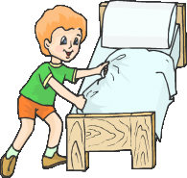
Susan and her mum  __________________________ | Ben, make the bed
Kitty, water the plants | Alex  __________________________

Worksheet 2 (B): Present Progressive
CHAN, Shuk Ling Heather
The Hong Kong Institute of Education

Information gap activity
You and your partner have to take turns to ask and answer questions using the present continuous tense. Finish the sentences and draw the actions as you listen.

Q: What is/are XXX doing?
A: XXX is/ are _____ing.

Student B
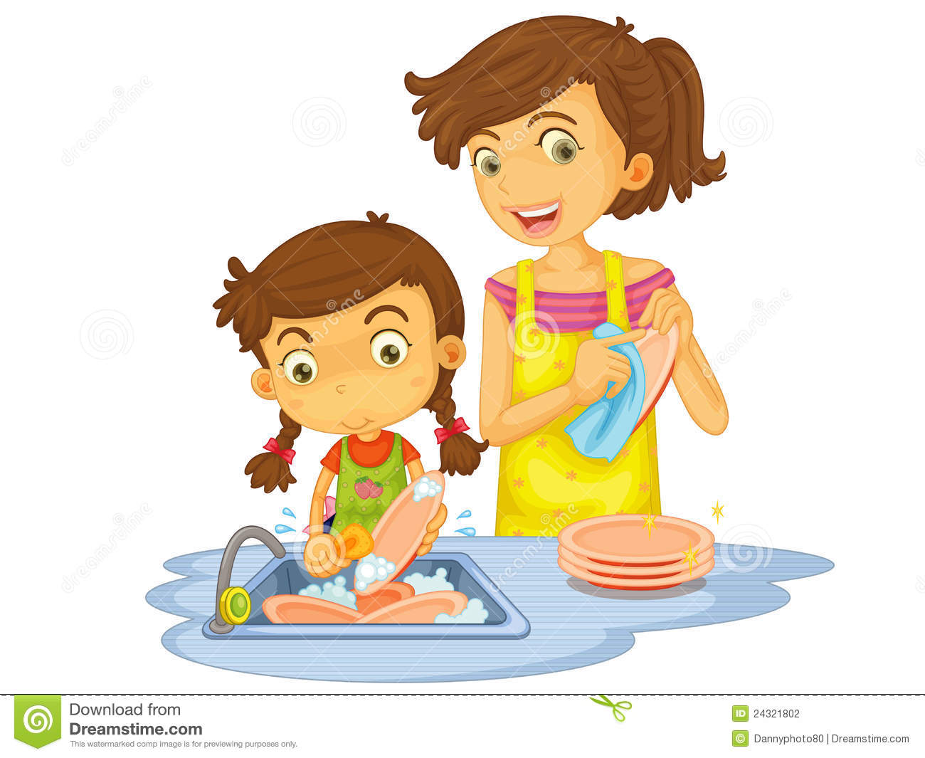
Susan and her mum, wash dishes | Ben  _________________________
Kitty  __________________________ | Alex, feed the dog

Worksheet 2 (A*) – for stronger students
Present Progressive
CHAN, Shuk Ling Heather
The Hong Kong Institute of Education

Information gap activity
You and your partner have to take turns to ask and answer questions using the present continuous tense. Finish the sentences and draw the actions as you listen.

Q: What is/are XXX doing?
A: XXX is/ are _____ing.

Student A
Susan and her mum  __________________________ | Ben  He __ _________ the bed.
Kitty  She __ ________the plants. | Alex  __________________________
Worksheet 2 (B*) – for stronger students
Present Progressive
CHAN, Shuk Ling Heather
The Hong Kong Institute of Education

Information gap activity
You and your partner have to take turns to ask and answer questions using the present continuous tense. Finish the sentences and draw the actions as you listen.

Q: What is/are XXX doing?
A: XXX is/ are _____ing.

Student B
Susan and her mum  They ___ ________ dishes. | Ben  _________________________
Kitty  __________________________ | Alex  He ___ ________ the dog.

