LI, Man Yee Karena
The Hong Kong Institute of Education
Worksheet 1
Name:____________________ Class:_____( ) Date:_____________________
What do people around the world eat for breakfast / lunch? Watch the video and fill in the blanks.
America  = ______________  ______________ | people eat bacon. | This is an ____________________ breakfast.
Mexico | _______________ people eat beans. | 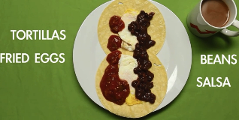  This is a ____________________ breakfast.
Brazil | _______________ people eat fruit. | 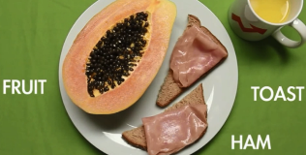  This is a ____________________ breakfast.
France | _______________ people eat chicken. | This is part of a ____________________ lunch.
Sweden | _______________ people eat hard-boiled eggs. | 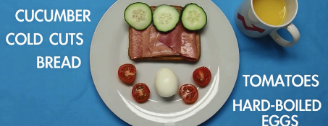  This is a ____________________ breakfast.
Britain  =____________________________ | ____________people eat yogurt. | 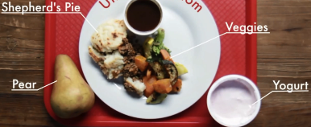
China | We can eat Taro Pie in _______________ McDonald’s. | 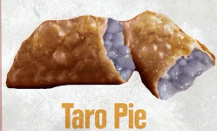  This is from a ____________________ McDonald’s.
Japan | _______________ people eat white rice. | 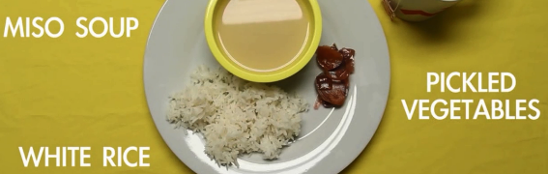  This is a ____________________ breakfast.

In the box below, write down all the adjectives for the countries mentioned in the video.

Look at the ending of each of the adjectives and put the adjectives in groups.
Ending of the words
-n / -an / -ian | -ish | -ese | others
Put down other examples
IndiaIndian

Card game for different levels of learners
Memory game (Lower ability)
China | Chinese | Britain | British
Sweden | Swedish | India | Indian
Austria | Austrian | Brazil | Brazilian
Spain | Spanish | Italy | Italian
Mexico | Mexican | America | American
Australia | Australian | France | French

Memory game (Intermediate)
China | -ese | Britain | -ish
Sweden | -ish | India | -n
Austria | -n | Brazil | -ian
Spain | -ish | Italy | -an
Mexico | -an | America | -n
Australia | -n | Indonesia | -n

Memory game (Higher ability)
China | ________ people love dragons. | Britain | Harry Potter is a _____ movie.
Sweden | _______ people eat meatballs. | India | _______ curry is spicy.
Thailand | _______ people celebrate the Water Festival. | Brazil | _______ people love football.
Spain | Barcelona is a _______ city. | Italy | _______ people eat pizza.
Mexico | _______ people in the past wore big hats. | America | Obama is an _______ president.
Australia | _______ people can see kangaroos easily. | France | Eiffel Tower is a _________ sightseeing spot.

Sample brochures-Student A
Asia’s most adventurous countries  -Thailand & Malaysia | Thailand  Water Festival  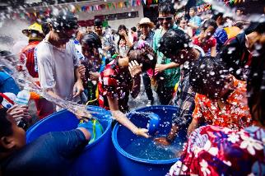  In Thailand, the Water Festival is to celebrate Thai New Year. Thai people believe water can wash away bad luck. It is exciting! | ______________  Diving  Diving is a popular activity in _________________ since the water is very clear. You can learn diving from a local professional ___________________ diver.  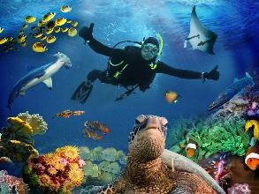

Sample brochures Student B
Asia’s most adventurous countries  -Thailand & Malaysia | ______________  Water Festival  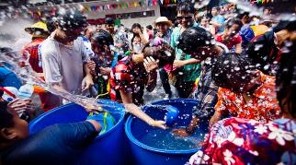  In _________________, the Water Festival is to celebrate _______________ New Year. _______________ people believe water can wash away bad luck. It is exciting! | Malaysia  Diving  Diving is a popular activity in Malaysia since the water is very clear. You can learn diving from a local professional Malaysian diver.

Brochures collected –Samples
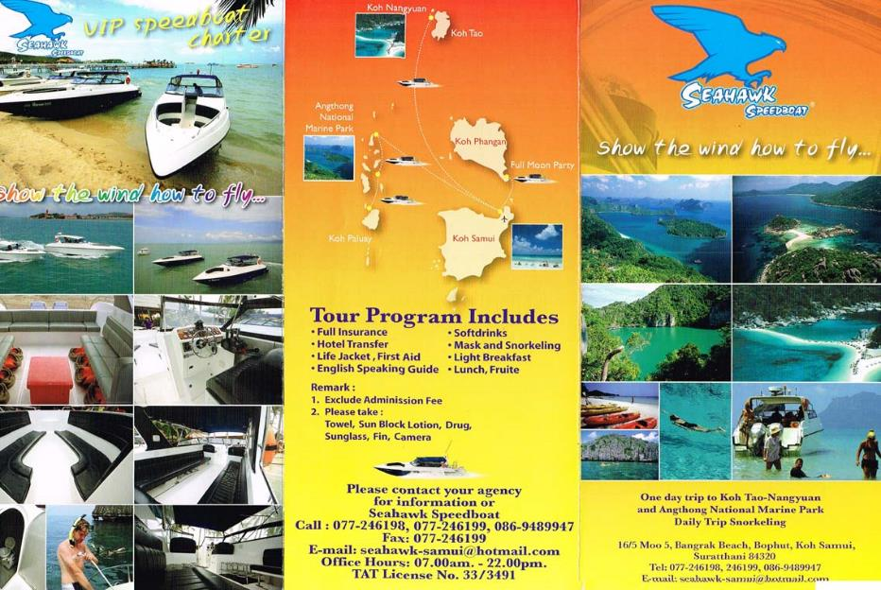
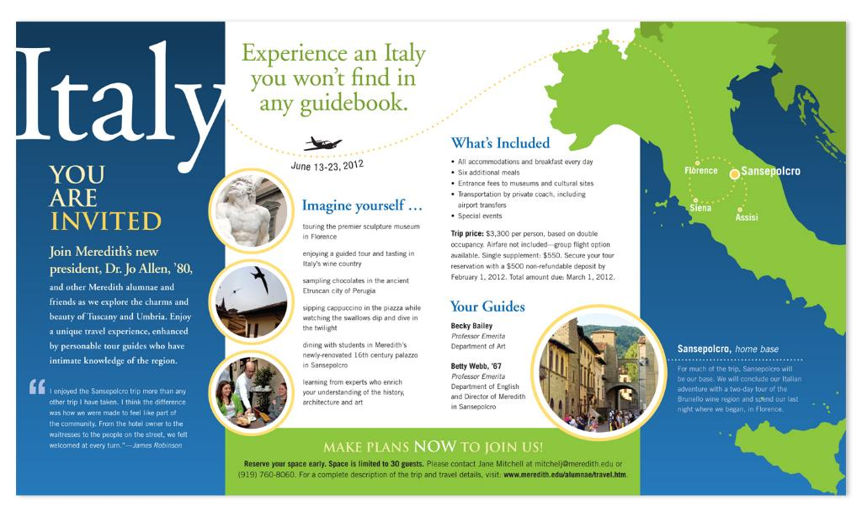

Mind map sheet

References:

https://www.youtube.com/watch?v=ry1E1uzPSU0 What Does the World Eat for Breakfast? by BuzzFeedYellow

https://www.youtube.com/watch?v=9ORiKlpasOw 37 McDonald's Foods You Probably Haven't Tried by BuzzFeedYellow

https://www.youtube.com/watch?v=Po0O9tRXCyA School Lunches around the World

