Adjectives of Country Names
LI, Man Yee Karena, The Hong Kong Institute of Education

Lesson 1

Comprehensible input – article - Food around the World
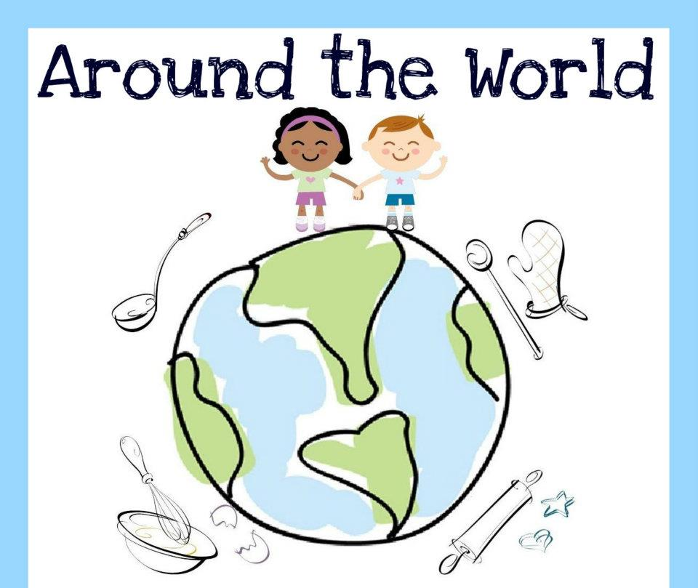  Food |  |  | Curry is from India. It is Indian food.  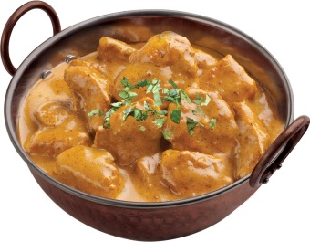 |  | Pizza is from Italy. It is Italian food.  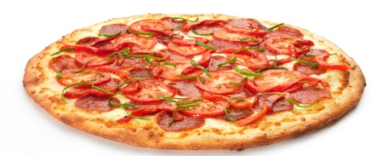
 |  |  |  |  | Meatballs are from Sweden. They are Swedish food. |  | 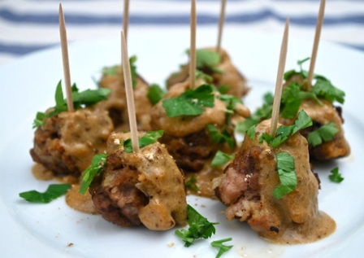
 |  |  | Sushi is from Japan. It is Japanese food. 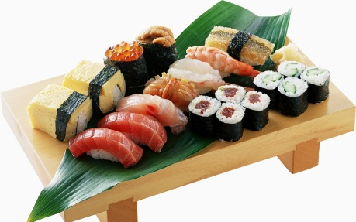
Tea egg is from China. It is Chinese food. | 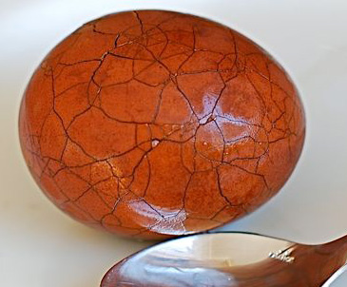
 |  |  |  |  | Long bread is from France. It is French food. |  | 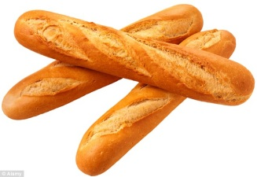
Fish and chips are from Britian. They are British food. |  | 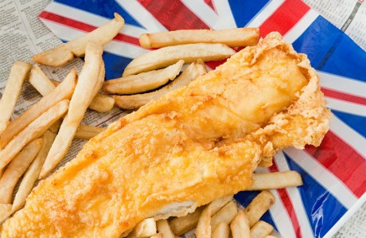 |  | Tom Yum Soup is from Thailand. It is Thai food. |  | 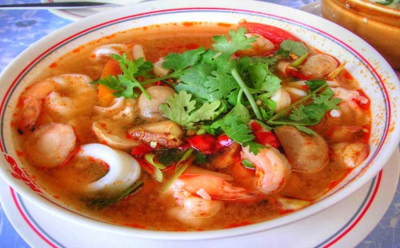

1. Circle all the country names and underline their adjectives in the article.
e.g. Curry is from India. It is Indian food.

2. Read the text again, and fill in the table below.
Country | + _______  n | Adjectives | Food
India |  | Indian | Curry
 |  |  | Pizza
 |  |  | Meatballs
 |  |  | Sushi
 |  |  | Tea egg
 |  |  | Fish and chips
 |  |  | Long bread
 |  |  | Tom Yum soup

3. Put the adjectives into groups.
+ n/ ian
+ ese
+ ish
Others

4. Do you like eating food around the world? What do you like to eat?
____________________________________________________________________________

5. Ask your neighbour the same questions!
(Do you like eating food around the world? What do you like to eat?)

Cards for the matching game
-n/ian | India | Italy | America | Australia | Canada | Malaysia
-ese | China | Japan | Taiwan | Vietnam | China | Japan
-ish | Britain | Sweden | England | Spain | Finland | Ireland
Others | France | Thailand | Germany | Philippines | Greece | France

Lesson 2
Sample floor plan of the food court for the information gap activity
Student A
Miss Li’s Food Court
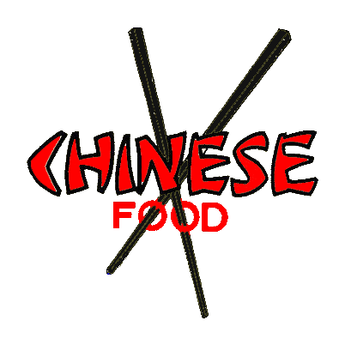 |  | 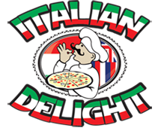
You can eat ________ here.  They are from ________.  They are__________ food. | You can eat Tom Yum soup here.  It is from ___________.  It is __________food. |  | You can eat pizza here.  It is from Italy.  It is Italian food.
Seats and tables
Student B
Miss Li’s Food Court
You can eat tea eggs here.  They are from China.  They are Chinese food. | You can eat __________ here. It is from Thailand.  It is Thai food. | You can eat _______ here.  It is from ______.  It is _______ food.
Seats and tables

Student writing worksheet
My Dream Food Court
______________ Food Court
Seats and tables

Field Trip Worksheet
Field Trip to a Food Court
1. Choose your favourite three counters, draw their logos and write about them.
Logo | e.g.
What can we eat there? | e.g. You can eat curry here. It is from India. It is Indian food.
Photos | 