Worksheet – Comparatives (Student’s Version)
CHAN, Shuk Ling Heather
The Hong Kong Institute of Education

- Read a travel magazine article below. Circle the adjectives.
Travel magazine (Part 1)
Hong Kong is a paradise for tourists. Tsim Sha Tsui and Mong Kok are popular places for shopping and dining. There are some big shopping malls in Tsim Sha Tsui and Mong Kok. Harbour City in Tsim Sha Tsui is bigger than Langham Place in Mong Kok. You can go to Harbour City to buy luxury goods.
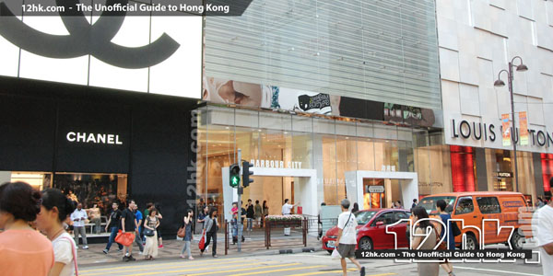Harbour City in Tsim Sha Tsui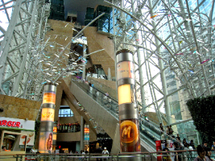Langham Place in Mong Kok

If you want to buy souvenirs, you can go to Ladies Market in Mong Kok. The things there are cheaper than those in Tsim Sha Tsui. You may find some restaurants there. The food in Mong Kok is yummier than that in Tsim Sha Tsui.
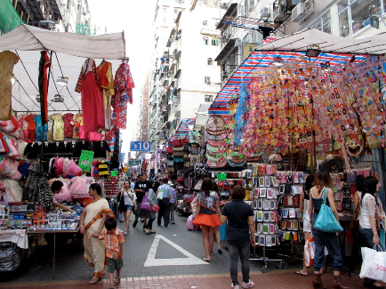Ladies Market in Mong Kok

If you want to see the beautiful night view in Hong Kong, the view of Victoria Harbour in Tsim Sha Tsui is more beautiful than the view in Mong Kok.
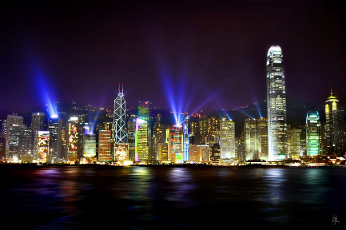Victoria Harbour in Tsim Sha Tsui
- Refer to the magazine article. Write the base form and comparative adjectives in the table below according to their number of syllables.
One syllable
Base form | Comparative
1.
2.
Two syllables
Base form | Comparative
1.
Three or more syllables
Base form | Comparative
1.
2.

- Read the following magazine article and draw emojis to show the different levels of crowdedness and dining costs in Tsim Sha Tsui and Mong Kok.

Travel magazine (Part 2)
Hong Kong is a famous city full of tourists from all over the world. Tsim Sha Tsui is always crowded but Mong Kok is more crowded. You can enjoy shopping or dining there! If you like Korean food, a restaurant in Tsim Sha Tsui is highly recommended: Excellent Kimchi Restaurant. Although it is more expensive to dine there than in some Korean restaurants in Mong Kok, the soy sauce crab is very tasty!

 | Tsim Sha Tsui | Mong Kok
Crowdedness (crowded)
Dining costs (expensive)

- 0 emoji = the least
- 5 emojis = the most
- Compare the rides, cartoon characters and ticket prices in Ocean Park and Hong Kong Disneyland using the structure more … than.

- The rides in Ocean Park are _______ ___________ _______ the rides in Disneyland.

- The cartoon characters in __________________ are _______ ___________ _______ the cartoon characters in _______________________.

- ___________________________ tickets are/is* _______ ______________ _______ _________________________ tickets.
(* circle the correct answer)

 | Ocean Park | Disneyland
Rides (exciting) | 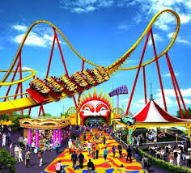 | 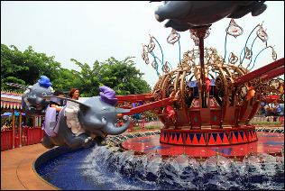
Cartoon characters (amusing) | 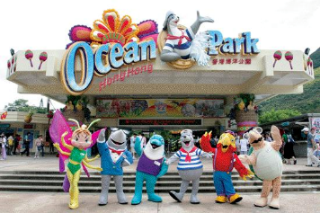 | 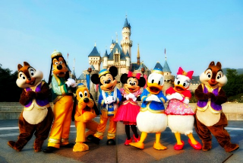
Tickets
(expensive)

- Find two kinds of food at home, and recommend them to tourists. Draw them in the boxes below. Circle the suitable adjectives to describe the food items you choose. Write at least three sentences to compare the food items using comparatives. You may use your own adjectives.

Circle the suitable adjectives to describe the two food items above.
sour sweet bitter spicy salty delicious expensive

- ____________________________________________________
- ____________________________________________________
- ____________________________________________________
Information Gap Activity (Version A)
Work in pairs. Ask and answer questions to compare the two Korean restaurants, Excellent Kimchi Restaurant and Fantastic Korean Restaurant. Draw emojis in the boxes. Decide which restaurant to recommend to tourists.

e.g. Q: Which restaurant is more comfortable?
A: Fantastic Korean Restaurant is more comfortable.

Version A
 | Excellent Kimchi Restaurant | Fantastic Korean Restaurant
- Comfortable
- Popular
- Big
- Delicious
- Trendy
- Expensive

We would like to recommend (Excellent Kimchi Restaurant / Fantastic Korean Restaurant)* to tourists.
*Circle the answer.
Information Gap Activity (Version B)
Work in pairs. Ask and answer questions to compare the two Korean restaurants, Excellent Kimchi Restaurant and Fantastic Korean Restaurant. Draw emojis in the boxes. Decide which restaurant to recommend to tourists.

e.g. Q: Which restaurant is more comfortable?
A: Fantastic Korean Restaurant is more comfortable.

Version B
 | Excellent Kimchi Restaurant | Fantastic Korean Restaurant
- Comfortable
- Popular
- Big
- Delicious
- Trendy
- Expensive

We would like to recommend (Excellent Kimchi Restaurant / Fantastic Korean Restaurant)* to tourists.
*Circle the answer.

