Making Comparison
WONG Tsz Yu Renee
The Hong Kong Institute of Education

Name: ______________ Class: ______________ ( )

Activity 1: Adjectives with a different number of syllables

One-syllable Adjectives | One-syllable Adjectives | Adjectives with 3 or more than 3 syllables

Note-taking:

 | Comparative form
Adjectives with 1-2 syllables | __________ -er + than
Adjectives with 3 or more than syllables

Note: Some adjectives with two syllables can have either comparative form (e.g. quieter, more quiet)
Activity 2: Miss Wong’s preferences

Activity 3: What do you think?
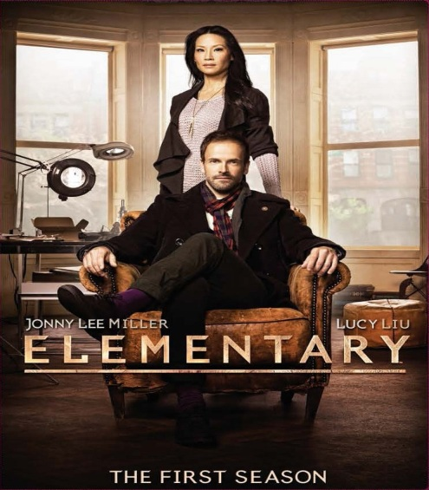
https://youtu.be/aaorTM2wB9o https://www.youtube.com/watch?v=ff-XiZzJLxw
- Attractiveness of the actor
VS
I think the actor in ___________ is more ___________ than that in __________
because___________________________________________________________.

- Attractiveness of the actress

VS
I think the actress in _____________ is _______ ___________ than that in ____________ because _____________________________________________
_________________________________________________________.

- Fame of the actor

VS
I think the actor in __________ ____ ________ _________ than _______ __ _____
because ___________________________________________________________.

- Fame of the actress
VS
I think ______________________________________________________________
because ____________________________________________________________.

- Interesting plot?
VS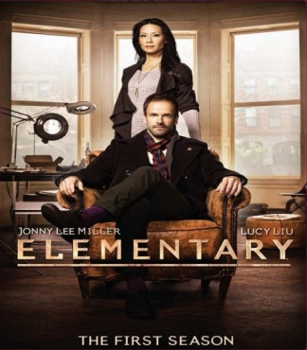
I think ____________________________________________________________
because ___________________________________________________________.

- Suitable for teenagers?

VS
I think _____________________________________________________________
because ____________________________________________________________.

Activity 4 Making Recommendations
In pairs, choose a specific subject for making recommendations to class. You can recommend a picnic site, a book, a movie, a restaurant, etc. Surf on the internet to find out more information about the topic, if necessary. Remember to use comparatives in the recommendation. Present your recommendation to the class in the next lesson.

