Prepositions
LEE, Gwangmin
The Hong Kong Institute of Education

Matching card game (Lesson 1)

Add pictures of target prepositions.

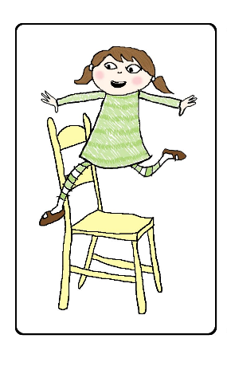 | on | 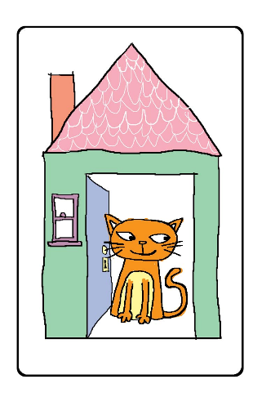 | in
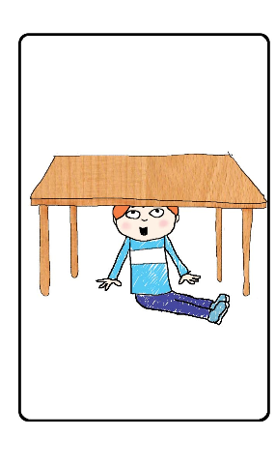 | under | 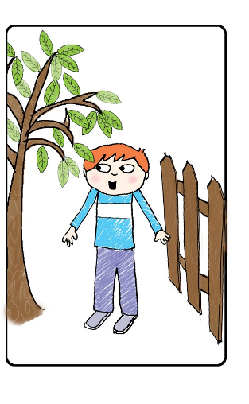 | between
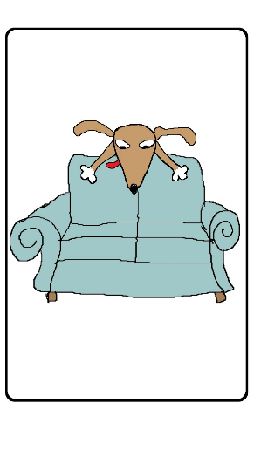 | behind | 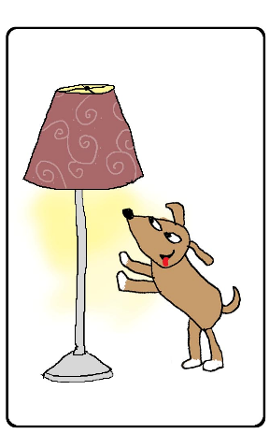 | next to

Worksheet (Lesson 2)

Part 1
Song listening
Where is the school?

Where is the school? Where is the school?
It’s next to the park.
Across from the bank,
In front of the bus stop,
And behind the library.

Where is the school? Where is the school?
It’s next to the park,
Across from the bank,
In front of the bus stop,
And behind the library.

Part 2

Where is the school?

Listen to the song “Where is the school?” again. Draw the map of the school. Color your drawing.

- The school is _________________________________ to the park.
- The school is _____________________________________ from the bank.
- The school is _________________________________________ the bus stop.
- The school is ______________________________________ the library.

Worksheet (Lesson 3)

Miss Lee’s House

Left Right

Police Station | 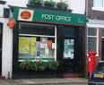Post Office |  | Bookstore | Bank
 |  | Boundary Street
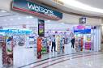Watsons | 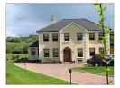Miss Lee’s house |  | 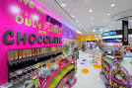 Candy Shop | Fast Food Shop
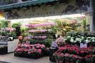Flower Shop | ParknShop |  | Jewellery Shop | 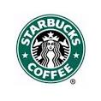Cafe
You are here

Information Gap Activity (Lesson 3)

Student A

You are Peter. You have moved to a new home. You want to do some shopping near your home, but you know only some of the shops.

- Ask your partner where the shops are and fill in the blanks.
For example,
“Excuse me, I want to buy _______________________. Where is the ________________?”

Your shopping list:
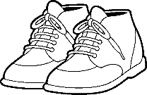 |  | 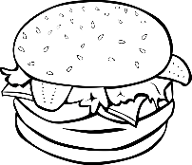 | 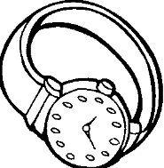

- Give directions to your partner when he/she asks you.
For example,
“Go straight. Take the first/second turning on the right/left. There’s one next to/opposite the _______________________. / There’s one behind /in front of the _______________.”

Left Right

Book Shop | 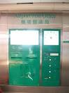Post Office |  | 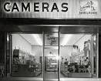Camera Shop | Bank
 |  | Hennessy Road
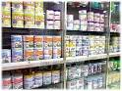  Chemist’s | a. |  | Candy Shop | b.
c. | 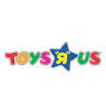Toy Shop |  | d. | Cafe
 |  | Johnston Road
Restaurant | 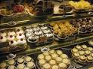Cake Shop |  | 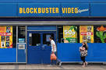Video Shop | 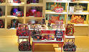Handbag Shop
You are here

Student B

You are Jane. You have moved to a new home. You want to do some shopping near your home, but you know only some of the shops.

- Ask your partner where the shops are and fill in the blanks.
For example,
“Excuse me, I want to buy _______________________. Where is the ________________?”

Your shopping list:
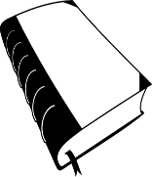 |  | 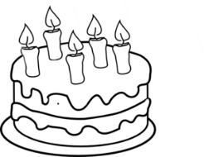 | 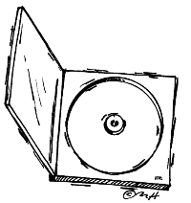

- Give directions to your partner when he/she asks you.
For example,
“Go straight. Take the first/second turning on the right/left. There’s one next to/opposite the _______________________. / There’s one behind / in front of the _______________.”

Left Right

1. | Post Office |  | 2. | Bank
 |  | Hennessy Road
Chemist’s | Shoe Shop |  | Candy Shop | Fast Food Shop
Flower Shop | Toy Shop |  | Jewellery Shop | Cafe
 |  | Johnston Road
Restaurant | 3. |  | Video Shop | 4.
You are here

