Worksheet 1 (Students’ version)
Autobiography (Present Perfect and Past tense)
LU Yuxi Celine & MAO Yuting Yvette
The Hong Kong Institute of Education

- Listen to the teacher’s autobiography and pay close attention to the verbs used. Circle the words you hear.
(1)  a. was born  b. have been born  c. bear | (2)  a. lived  b. have lived  c. live | (3)  a. was 22  b. have been 22  c. am 22 | (4)  a. graduated  b. have graduated  c. graduates
(5)  a. went  b. have gone  c. goes | (6)  a. was 19  b. have been 19 c. am 19 | (7)  a. met  b. have met  c. meet | (8)  a. fell in love  b. have fallen in love  c. fall in love
(9)  a. married  b. have married  c. marry | (10)  a. moved  b. have moved  c. move | (11)  a. got  b. have got  c. get | (12)  a. worked  b. have worked  c. work
(13)  a. had  b. have had  c. have | (14)  a. was born  b. has been born  c. bears | (15)  a. lived  b. have lived  c. live | (16)  a. spent  b. have spent  c. spend
(17)  a. travelled  b. have travelled  c. travel | (18)  a. loved  b. have loved  c. love | (19)  a. spent  b. have spent  c. spend
- Listen again and complete the teacher’s timeline.
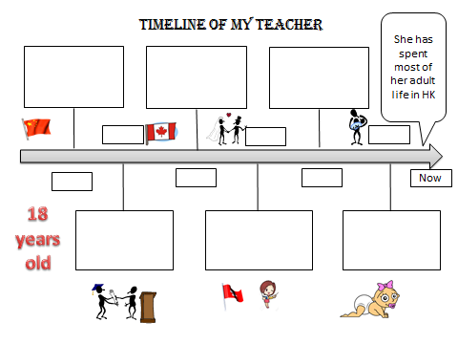

3) In pairs, construct the text and try to make it as close to the original biography as possible.

Worksheet 1 (Teacher’s version)

- Listen to the teacher’s autobiography and pay close attention to the verbs used. Circle the words you hear.
(1)  a. was born  b. have been born  c. bear | (2)  a. lived  b. have lived  c. live | (3)  a. was 22  b. have been 22  c. am 22 | (4)  a. graduated  b. have graduated  c. graduates
(5)  a. went  b. have gone  c. goes | (6)  a. was 19  b. have been 19 c. am 19 | (7)  a. met  b. have met  c. meet | (8)  a. fell in love  b. have fallen in love  c. fall in love
(9)  a. married  b. have married  c. marry | (10)  a. moved  b. have moved  c. move | (11)  a. got  b. have got  c. get | (12)  a. worked  b. have worked  c. work
(13)  a. had  b. have had  c. have | (14)  a. was born  b. has been born  c. bears | (15)  a. lived  b. have lived  c. live | (16)  a. spent  b. have spent  c. spend
(17)  a. travelled  b. have travelled  c. travel | (18)  a. loved  b. have loved  c. love | (19)  a. spent  b. have spent  c. spend

- Listen again and complete the teacher’s timeline.
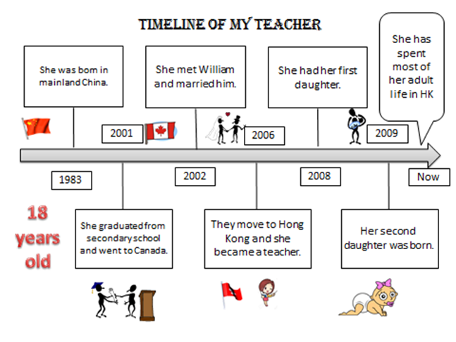

Worksheet 2

Listen to the biography of Li Ka-shing and fill in the gaps.
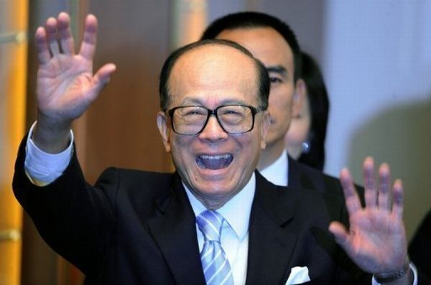
Li Ka-shing (1) ________________ in 1928 in mainland China but he (2) ________________ most of his adult life in Hong Kong. He (3) ________________ school before 15 and the family (4) ________________ to Hong Kong. He (5) _______________ a job in a plastic trading company. In 1950, he (6) __________________ his own company, Cheung Kong Industries. Li (7) _________________ and (8) ___________________a site by himself. In 1971, Li officially (9) _________________ his real estate development company Cheung Kong (長江實業), named after Cheung Kong, (Chang Jiang or the Yangtze River) the longest river in China. He (10) ______________________ Cheung Kong company for 44 years.
Although Li is wealthy, he (11) __________________________ a reputation for leading a simple lifestyle. He is known to wear simple black shoes and an inexpensive Seiko wristwatch, which is at odds with the house he owns in one of Hong Kong's most expensive districts, Deep Water Bay in Hong Kong Island. Besides, Li (12) _________________________ as one of Asia's most generous people because he (13) _________________________ over US $1.41 billion to date to charity.

Worksheet 3 Writing

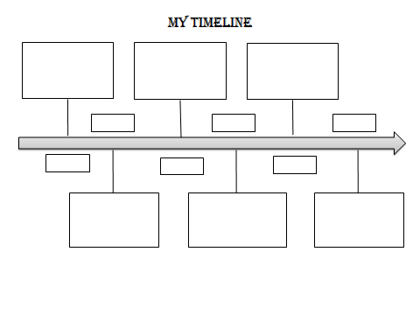
Part One: Draw your own timeline (you can draw pictures as well!)

You may refer to the teacher’s timeline

Part Two
(1) Work in pairs and tell your partner your life experience.
(2) Listen to your partner’s life experience and write a biography for your partner.

______________________________________________________________________________
______________________________________________________________________________
______________________________________________________________________________
______________________________________________________________________________
______________________________________________________________________________
______________________________________________________________________________
______________________________________________________________________________
______________________________________________________________________________
______________________________________________________________________________
______________________________________________________________________________
______________________________________________________________________________
______________________________________________________________________________
______________________________________________________________________________
______________________________________________________________________________
______________________________________________________________________________
______________________________________________________________________________
______________________________________________________________________________
______________________________________________________________________________
______________________________________________________________________________
______________________________________________________________________________
______________________________________________________________________________
______________________________________________________________________________
______________________________________________________________________________

Peer evaluation form

Read the checklist below and evaluate your partner’s writing about you by ticking the correct box below.
Item | Writing rubrics | Strongly agree | Agree | Disagree | Strongly disagree
 | Able to use past tense correctly.
2. | Able to use present perfect tense correctly.
3. | Ideas and contents are accurate.

Appendix 1:
Teacher’s autobiography
I was born in mainland China in 1983. I lived there until I was 18. I graduated from a secondary school and then I went to Canada for university. When I was 19, I met William and fell in love with him. I married William in Canada. In 2006, my family and I moved to Hong Kong. I got a job in XXX School. I have worked as an English teacher since then. Two years later, we had our first daughter here in Hong Kong. Our second girl was born in 2009.
My family and I have lived in Hong Kong for nine years and we often spend our holiday overseas. So far, we have travelled to 12 countries, such as England, Ireland and Italy. However, we love Hong Kong best. I have spent most of my adult life in Hong Kong!

Appendix 2 Text & Answer Key:
Li Ka-shing
Li Ka-shing was born in 1928 in mainland China. However, he has lived most of his adult life in Hong Kong. He left school when he was just 12. The whole family fled to Hong Kong in 1940. He then found a job in a plastic trading company and started to work there. In the year of 1950, he started his own company, Cheung Kong Industries. After that, he bought and developed a site by himself. In 1971, Li officially named his real estate development company Cheung Kong (長江實業). It is named after the Yangtze River, the longest river in China. Up to now, Cheung Kong Company has been open for 44 years.
In spite of his wealth, Li has cultivated a reputation for leading a simple lifestyle. He is known to wear simple black shoes and an inexpensive Seiko wristwatch, which is at odds with the house he owns in one of Hong Kong's most expensive districts, Deep Water Bay in Hong Kong Island. Besides, Li has been regarded as one of Asia's most generous people because he has donated over US $1.41 billion to date to charity.

(1) was born (2) has lived (3) left (4) moved / fled (5) found / got (6) started
(7) bought (8) developed (9) named (10) has opened (11) has cultivated
(12) has been regarded (13) has donated

