Worksheet – Weekly Activities
(Present Tense for Junior Primary)
LEE, Gwangmin
The Hong Kong Institute of Education

Lesson 2

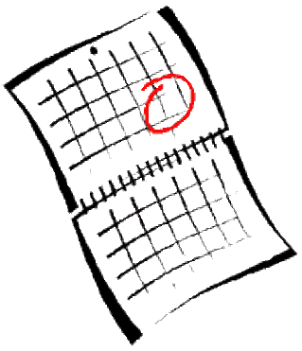

John and Sally want to play together after school. But they have things to do after school. They are talking to each other to find out the day when they can play together.

John: Sally, let’s go to the park and play together this week. What do you do on Mondays?

Sally: I play the piano on Mondays.
What do you do on Tuesdays?

John: I visit my grandparents on Tuesdays. What do you do on Wednesdays?

Sally: I am free on Wednesdays.

John: Oh sorry, I forgot that I study with my tutor on Wednesdays. What do you do on Thursdays?

Sally: I paint pictures on Thursdays. What do you do on Fridays?

John: I am free on Fridays! What do you do on Fridays?

Sally: I am free too! Let’s go to park after school this Friday.
Information Gap Activity

Student A

You want to find a day when you and your partner can play together. Ask your partner for his/her weekly activities and find out the day when both of you are free.

Question:
“What do you do on ________________?”
Answer:
“I ___________________ on __________________”

When you do not have any weekly activities, you have to answer
“I am free on _______days!”

Sundays | Mondays | Tuesdays | Wednesdays | Thursdays | Fridays | Saturdays
Play the piano | Visit grandparents |  | Study with my tutor | Read books |  | Play with my dog

Listen to your partner’s reply and complete the following sentences.

- He/she ___________________________________ on _________________.
- He/she ___________________________________ on _________________.
- He/she ________________________________________________________.
- He/she ________________________________________________________.
- He/she ________________________________________________________.
- He/she ________________________________________________________.
- He/she ________________________________________________________.

When can you play with your partner?

_____________________________________________________________________________.

Student B

You want to find a day when you and your partner can play together. Ask your partner for his/her weekly activities and find out the day when both of you are free.

Question:
“What do you do on ________________?”
Answer:
“I ___________________ on __________________”

When you do not have any weekly activities, you have to answer
“I am free on _______days!”

Sundays | Mondays | Tuesdays | Wednesdays | Thursdays | Fridays | Saturdays
Visit grandparents | Study with my tutor |  | Watch cartoons |  | Read books | watch TV

Listen to your partner’s reply and complete the following sentences.

- He/she ___________________________________ on _________________.
- He/she ___________________________________ on _________________.
- He/she ________________________________________________________.
- He/she ________________________________________________________.
- He/she ________________________________________________________.
- He/she ________________________________________________________.
- He/she ________________________________________________________.

When can you play with your partner?

_____________________________________________________________________________.

Lesson 3
Class Survey

- Fill in the blanks of “my weekly activity”.
- Then Find out who does the same activity as you by asking the question “What do you do on _________________?”.

Examples of activity:
Study with my tutor / visit the grandparents / play the piano / …

Days of week | My weekly activity | Who does the same activity as you?
Sunday | e.g. I play chess with my brother. | John goes swimming.  Nancy plays chess.  Tom visits grandparents.
Monday
Tuesday
Wednesday
Thursday
Friday
Saturday

Lesson 4 Worksheet – Class Survey Report

Report on the class survey. You need to complete the sentences below and draw your favorite activity in the box.

e.g. Nancy and I play chess on Sundays.
John goes swimming on Sundays.
Tom visits grandparents on Sundays.

______________ and I _____________________________________ on Mondays.
_____________________________________________________________.
_____________________________________________________________.
_____________________________________________________________.
_____________________________________________________________.
_____________________________________________________________.
_____________________________________________________________.
_____________________________________________________________.
_____________________________________________________________.
_____________________________________________________________.

